Since the invention of computers or machines, their capability to perform various tasks went on growing exponentially. Humans have developed the power of computer systems in terms of their diverse working domains, their increasing speed, and reducing size with respect to time.

A branch of Computer Science named *Artificial Intelligence* pursues creating the computers or machines as intelligent as human beings.

**What is Artificial Intelligence?**

According to the father of Artificial Intelligence, John McCarthy, it is *“The science and engineering of making intelligent machines, especially intelligent computer programs”.*

Artificial Intelligence is a way of **making a computer, a computer-controlled robot, or a software think intelligently**, in the similar manner the intelligent humans think.

AI is accomplished by studying how human brain thinks, and how humans learn, decide, and work while trying to solve a problem, and then using the outcomes of this study as a basis of developing intelligent software and systems.

**Philosophy of AI**

While exploiting the power of the computer systems, the curiosity of human, lead him to wonder, *“Can a machine think and behave like humans do?”*

Thus, the development of AI started with the intention of creating similar intelligence in machines that we find and regard high in humans.

**Goals of AI**

* **To Create Expert Systems** − The systems which exhibit intelligent behavior, learn, demonstrate, explain, and advice its users.
* **To Implement Human Intelligence in Machines** − Creating systems that understand, think, learn, and behave like humans.

**What Contributes to AI?**

Artificial intelligence is a science and technology based on disciplines such as Computer Science, Biology, Psychology, Linguistics, Mathematics, and Engineering. A major thrust of AI is in the development of computer functions associated with human intelligence, such as reasoning, learning, and problem solving.

Out of the following areas, one or multiple areas can contribute to build an intelligent system.

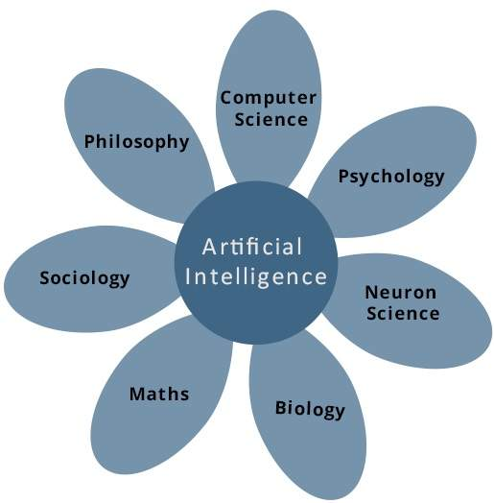

**Programming Without and With AI**

The programming without and with AI is different in following ways −

|  |  |
| --- | --- |
| **Programming Without AI** | **Programming With AI** |
| A computer program without AI can answer the **specific** questions it is meant to solve. | A computer program with AI can answer the **generic** questions it is meant to solve. |
| Modification in the program leads to change in its structure. | AI programs can absorb new modifications by putting highly independent pieces of information together. Hence you can modify even a minute piece of information of program without affecting its structure. |
| Modification is not quick and easy. It may lead to affecting the program adversely. | Quick and Easy program modification. |

**What is AI Technique?**

In the real world, the knowledge has some unwelcomed properties −

* Its volume is huge, next to unimaginable.
* It is not well-organized or well-formatted.
* It keeps changing constantly.

AI Technique is a manner to organize and use the knowledge efficiently in such a way that −

* It should be perceivable by the people who provide it.
* It should be easily modifiable to correct errors.
* It should be useful in many situations though it is incomplete or inaccurate.

AI techniques elevate the speed of execution of the complex program it is equipped with.

**Applications of AI**

AI has been dominant in various fields such as −

* **Gaming** − AI plays crucial role in strategic games such as chess, poker, tic-tac-toe, etc., where machine can think of large number of possible positions based on heuristic knowledge.
* **Natural Language Processing** − It is possible to interact with the computer that understands natural language spoken by humans.
* **Expert Systems** − There are some applications which integrate machine, software, and special information to impart reasoning and advising. They provide explanation and advice to the users.
* **Vision Systems** − These systems understand, interpret, and comprehend visual input on the computer. For example,
  + A spying aeroplane takes photographs, which are used to figure out spatial information or map of the areas.
  + Doctors use clinical expert system to diagnose the patient.
  + Police use computer software that can recognize the face of criminal with the stored portrait made by forensic artist.
* **Speech Recognition** − Some intelligent systems are capable of hearing and comprehending the language in terms of sentences and their meanings while a human talks to it. It can handle different accents, slang words, noise in the background, change in human’s noise due to cold, etc.
* **Handwriting Recognition** − The handwriting recognition software reads the text written on paper by a pen or on screen by a stylus. It can recognize the shapes of the letters and convert it into editable text.
* **Intelligent Robots** − Robots are able to perform the tasks given by a human. They have sensors to detect physical data from the real world such as light, heat, temperature, movement, sound, bump, and pressure. They have efficient processors, multiple sensors and huge memory, to exhibit intelligence. In addition, they are capable of learning from their mistakes and they can adapt to the new environment.

**History of AI**

Here is the history of AI during 20th century −

|  |  |
| --- | --- |
| **Year** | **Milestone / Innovation** |
| 1923 | Karel Čapek play named “Rossum's Universal Robots” (RUR) opens in London, first use of the word "robot" in English. |
| 1943 | Foundations for neural networks laid. |
| 1945 | Isaac Asimov, a Columbia University alumni, coined the term *Robotics*. |
| 1950 | Alan Turing introduced Turing Test for evaluation of intelligence and published *Computing Machinery and Intelligence.* Claude Shannon published *Detailed Analysis of Chess Playing* as a search. |
| 1956 | John McCarthy coined the term *Artificial Intelligence*. Demonstration of the first running AI program at Carnegie Mellon University. |
| 1958 | John McCarthy invents LISP programming language for AI. |
| 1964 | Danny Bobrow's dissertation at MIT showed that computers can understand natural language well enough to solve algebra word problems correctly. |
| 1965 | Joseph Weizenbaum at MIT built *ELIZA*, an interactive problem that carries on a dialogue in English. |
| 1969 | Scientists at Stanford Research Institute Developed *Shakey*, a robot, equipped with locomotion, perception, and problem solving. |
| 1973 | The Assembly Robotics group at Edinburgh University built *Freddy*, the Famous Scottish Robot, capable of using vision to locate and assemble models. |
| 1979 | The first computer-controlled autonomous vehicle, Stanford Cart, was built. |
| 1985 | Harold Cohen created and demonstrated the drawing program, *Aaron*. |
| 1990 | Major advances in all areas of AI −   * Significant demonstrations in machine learning * Case-based reasoning * Multi-agent planning * Scheduling * Data mining, Web Crawler * natural language understanding and translation * Vision, Virtual Reality * Games |
| 1997 | The Deep Blue Chess Program beats the then world chess champion, Garry Kasparov. |
| 2000 | Interactive robot pets become commercially available. MIT displays *Kismet*, a robot with a face that expresses emotions. The robot *Nomad* explores remote regions of Antarctica and locates meteorites. |

**What is Intelligence?**

The ability of a system to calculate, reason, perceive relationships and analogies, learn from experience, store and retrieve information from memory, solve problems, comprehend complex ideas, use natural language fluently, classify, generalize, and adapt new situations.

**Types of Intelligence**

As described by Howard Gardner, an American developmental psychologist, the Intelligence comes in multifold −

|  |  |  |
| --- | --- | --- |
| **Intelligence** | **Description** | **Example** |
| Linguistic intelligence | The ability to speak, recognize, and use mechanisms of phonology (speech sounds), syntax (grammar), and semantics (meaning). | Narrators, Orators |
| Musical intelligence | The ability to create, communicate with, and understand meanings made of sound, understanding of pitch, rhythm. | Musicians, Singers, Composers |
| Logical-mathematical intelligence | The ability of use and understand relationships in the absence of action or objects. Understanding complex and abstract ideas. | Mathematicians, Scientists |
| Spatial intelligence | The ability to perceive visual or spatial information, change it, and re-create visual images without reference to the objects, construct 3D images, and to move and rotate them. | Map readers, Astronauts, Physicists |
| Bodily-Kinesthetic intelligence | The ability to use complete or part of the body to solve problems or fashion products, control over fine and coarse motor skills, and manipulate the objects. | Players, Dancers |
| Intra-personal intelligence | The ability to distinguish among one’s own feelings, intentions, and motivations. | Gautam Buddhha |
| Interpersonal intelligence | The ability to recognize and make distinctions among other people’s feelings, beliefs, and intentions. | Mass Communicators, Interviewers |

You can say a machine or a system is **artificially intelligent** when it is equipped with at least one and at most all intelligences in it.

**What is Intelligence Composed of?**

The intelligence is intangible. It is composed of −

* Reasoning
* Learning
* Problem Solving
* Perception
* Linguistic Intelligence

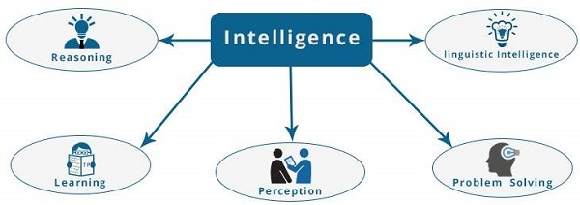

Let us go through all the components briefly −

* **Reasoning** − It is the set of processes that enables us to provide basis for judgement, making decisions, and prediction. There are broadly two types −

|  |  |
| --- | --- |
| **Inductive Reasoning** | **Deductive Reasoning** |
| It conducts specific observations to makes broad general statements. | It starts with a general statement and examines the possibilities to reach a specific, logical conclusion. |
| Even if all of the premises are true in a statement, inductive reasoning allows for the conclusion to be false. | If something is true of a class of things in general, it is also true for all members of that class. |
| Example − "Nita is a teacher. Nita is studious. Therefore, All teachers are studious." | Example − "All women of age above 60 years are grandmothers. Shalini is 65 years. Therefore, Shalini is a grandmother." |

* **Learning** − It is the activity of gaining knowledge or skill by studying, practising, being taught, or experiencing something. Learning enhances the awareness of the subjects of the study.

The ability of learning is possessed by humans, some animals, and AI-enabled systems. Learning is categorized as −

* + **Auditory Learning** − It is learning by listening and hearing. For example, students listening to recorded audio lectures.
  + **Episodic Learning** − To learn by remembering sequences of events that one has witnessed or experienced. This is linear and orderly.
  + **Motor Learning** − It is learning by precise movement of muscles. For example, picking objects, Writing, etc.
  + **Observational Learning** − To learn by watching and imitating others. For example, child tries to learn by mimicking her parent.
  + **Perceptual Learning** − It is learning to recognize stimuli that one has seen before. For example, identifying and classifying objects and situations.
  + **Relational Learning** − It involves learning to differentiate among various stimuli on the basis of relational properties, rather than absolute properties. For Example, Adding ‘little less’ salt at the time of cooking potatoes that came up salty last time, when cooked with adding say a tablespoon of salt.
  + **Spatial Learning** − It is learning through visual stimuli such as images, colors, maps, etc. For Example, A person can create roadmap in mind before actually following the road.
  + **Stimulus-Response Learning** − It is learning to perform a particular behavior when a certain stimulus is present. For example, a dog raises its ear on hearing doorbell.
* **Problem Solving** − It is the process in which one perceives and tries to arrive at a desired solution from a present situation by taking some path, which is blocked by known or unknown hurdles.

Problem solving also includes **decision making**, which is the process of selecting the best suitable alternative out of multiple alternatives to reach the desired goal are available.

* **Perception** − It is the process of acquiring, interpreting, selecting, and organizing sensory information.

Perception presumes **sensing**. In humans, perception is aided by sensory organs. In the domain of AI, perception mechanism puts the data acquired by the sensors together in a meaningful manner.

* **Linguistic Intelligence** − It is one’s ability to use, comprehend, speak, and write the verbal and written language. It is important in interpersonal communication.

**Difference between Human and Machine Intelligence**

* Humans perceive by patterns whereas the machines perceive by set of rules and data.
* Humans store and recall information by patterns, machines do it by searching algorithms. For example, the number 40404040 is easy to remember, store, and recall as its pattern is simple.
* Humans can figure out the complete object even if some part of it is missing or distorted; whereas the machines cannot do it correctly.

The domain of artificial intelligence is huge in breadth and width. While proceeding, we consider the broadly common and prospering research areas in the domain of AI −

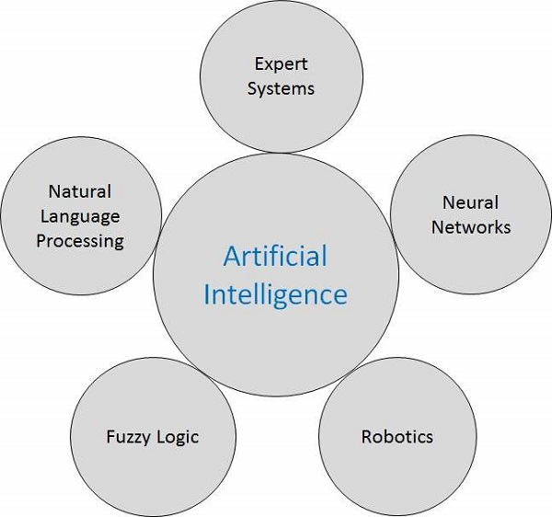

## Speech and Voice Recognition

These both terms are common in robotics, expert systems and natural language processing. Though these terms are used interchangeably, their objectives are different.

|  |  |
| --- | --- |
| **Speech Recognition** | **Voice Recognition** |
| The speech recognition aims at understanding and comprehending **WHAT** was spoken. | The objective of voice recognition is to recognize **WHO** is speaking. |
| It is used in hand-free computing, map, or menu navigation. | It is used to identify a person by analysing its tone, voice pitch, and accent, etc. |
| Machine does not need training for Speech Recognition as it is not speaker dependent. | This recognition system needs training as it is person oriented. |
| Speaker independent Speech Recognition systems are difficult to develop. | Speaker dependent Speech Recognition systems are comparatively easy to develop. |

### Working of Speech and Voice Recognition Systems

The user input spoken at a microphone goes to sound card of the system. The converter turns the analog signal into equivalent digital signal for the speech processing. The database is used to compare the sound patterns to recognize the words. Finally, a reverse feedback is given to the database.

This source-language text becomes input to the Translation Engine, which converts it to the target language text. They are supported with interactive GUI, large database of vocabulary, etc.

## Real Life Applications of AI Research Areas

There is a large array of applications where AI is serving common people in their day-to-day lives −

|  |  |  |
| --- | --- | --- |
| **Sr.No.** | **Research Areas** | **Example** |
| 1 | **Expert Systems**  Examples − Flight-tracking systems, Clinical systems. | Expert Systems Application |
| 2 | **Natural Language Processing**  Examples: Google Now feature, speech recognition, Automatic voice output. | NLP Application |
| 3 | **Neural Networks**  Examples − Pattern recognition systems such as face recognition, character recognition, handwriting recognition. | Neural Networks Application |
| 4 | **Robotics**  Examples − Industrial robots for moving, spraying, painting, precision checking, drilling, cleaning, coating, carving, etc. | Robotics Application |
| 5 | **Fuzzy Logic Systems**  Examples − Consumer electronics, automobiles, etc. | Fuzzy Logic Application |

## Task Classification of AI

The domain of AI is classified into **Formal tasks, Mundane tasks,** and **Expert tasks.**

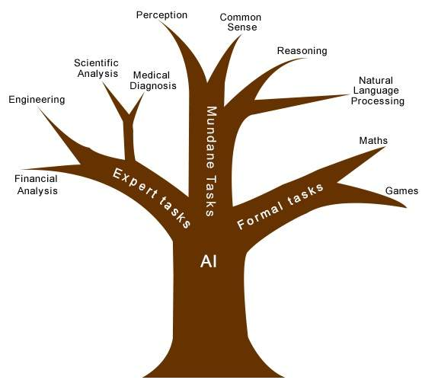

|  |  |  |
| --- | --- | --- |
| **Task Domains of Artificial Intelligence** | | |
| **Mundane (Ordinary) Tasks** | **Formal Tasks** | **Expert Tasks** |
| Perception   * Computer Vision * Speech, Voice | * Mathematics * Geometry * Logic * Integration and Differentiation | * Engineering * Fault Finding * Manufacturing * Monitoring |
| Natural Language Processing   * Understanding * Language Generation * Language Translation | Games   * Go * Chess (Deep Blue) * Ckeckers | Scientific Analysis |
| Common Sense | Verification | Financial Analysis |
| Reasoning | Theorem Proving | Medical Diagnosis |
| Planing |  | Creativity |
| Robotics   * Locomotive |  |  |

Humans learn **mundane (ordinary) tasks** since their birth. They learn by perception, speaking, using language, and locomotives. They learn Formal Tasks and Expert Tasks later, in that order.

For humans, the mundane tasks are easiest to learn. The same was considered true before trying to implement mundane tasks in machines. Earlier, all work of AI was concentrated in the mundane task domain.

Later, it turned out that the machine requires more knowledge, complex knowledge representation, and complicated algorithms for handling mundane tasks. This is the reason **why AI work is more prospering in the Expert Tasks domain** now, as the expert task domain needs expert knowledge without common sense, which can be easier to represent and handle.

An AI system is composed of an agent and its environment. The agents act in their environment. The environment may contain other agents.

## What are Agent and Environment?

An **agent** is anything that can perceive its environment through **sensors** and acts upon that environment through **effectors.**

* A **human agent** has sensory organs such as eyes, ears, nose, tongue and skin parallel to the sensors, and other organs such as hands, legs, mouth, for effectors.
* A **robotic agent** replaces cameras and infrared range finders for the sensors, and various motors and actuators for effectors.
* A **software agent** has encoded bit strings as its programs and actions.

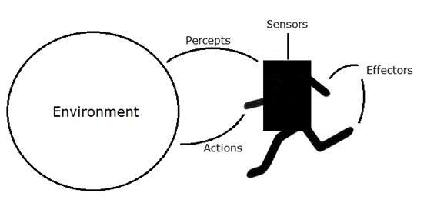

## Agent Terminology

* **Performance Measure of Agent** − It is the criteria, which determines how successful an agent is.
* **Behavior of Agent** − It is the action that agent performs after any given sequence of percepts.
* **Percept** − It is agent’s perceptual inputs at a given instance.
* **Percept Sequence** − It is the history of all that an agent has perceived till date.
* **Agent Function** − It is a map from the precept sequence to an action.

## Rationality

Rationality is nothing but status of being reasonable, sensible, and having good sense of judgment.

Rationality is concerned with expected actions and results depending upon what the agent has perceived. Performing actions with the aim of obtaining useful information is an important part of rationality.

## What is Ideal Rational Agent?

An ideal rational agent is the one, which is capable of doing expected actions to maximize its performance measure, on the basis of −

* Its percept sequence
* Its built-in knowledge base

Rationality of an agent depends on the following four factors −

* The **performance measures**, which determine the degree of success.
* Agent’s **Percept Sequence** till now.
* The agent’s **prior knowledge about the environment**.
* The **actions** that the agent can carry out.

A rational agent always performs right action, where the right action means the action that causes the agent to be most successful in the given percept sequence. The problem the agent solves is characterized by Performance Measure, Environment, Actuators, and Sensors (PEAS).

## The Structure of Intelligent Agents

Agent’s structure can be viewed as −

* Agent = Architecture + Agent Program
* Architecture = the machinery that an agent executes on.
* Agent Program = an implementation of an agent function.

### Simple Reflex Agents

* They choose actions only based on the current percept.
* They are rational only if a correct decision is made only on the basis of current precept.
* Their environment is completely observable.

**Condition-Action Rule** − It is a rule that maps a state (condition) to an action.

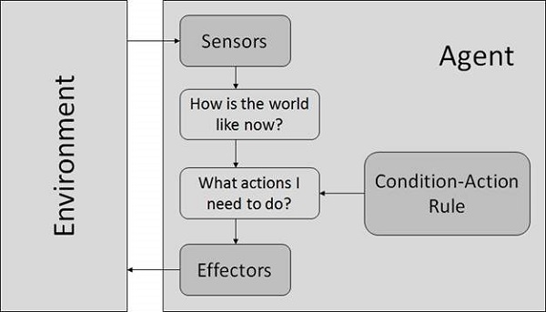

### Model Based Reflex Agents

They use a model of the world to choose their actions. They maintain an internal state.

**Model** − The knowledge about “how the things happen in the world”.

**Internal State** − It is a representation of unobserved aspects of current state depending on percept history.

**Updating the state requires the information about −**

* How the world evolves.
* How the agent’s actions affect the world.

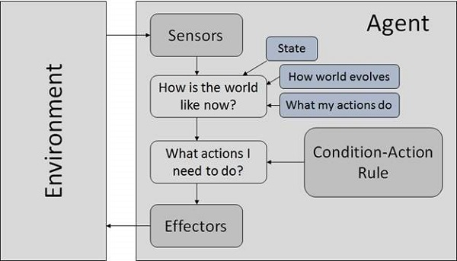

### Goal Based Agents

They choose their actions in order to achieve goals. Goal-based approach is more flexible than reflex agent since the knowledge supporting a decision is explicitly modeled, thereby allowing for modifications.

**Goal** − It is the description of desirable situations.

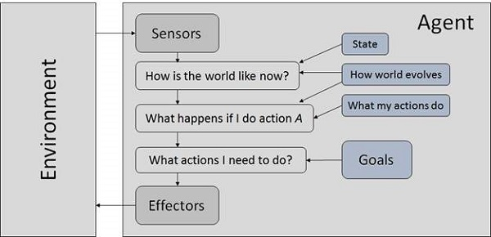

### Utility Based Agents

They choose actions based on a preference (utility) for each state. Goals are inadequate when −

* There are conflicting goals, out of which only few can be achieved.
* Goals have some uncertainty of being achieved and you need to weigh likelihood of success against the importance of a goal.

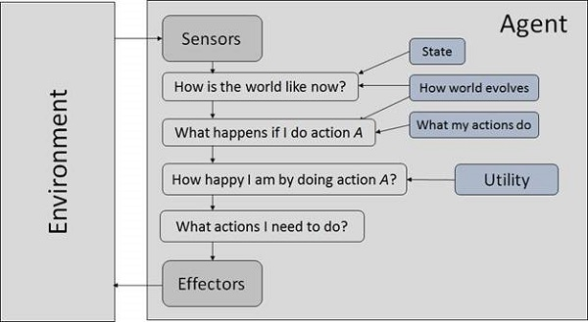

## Nature of Environments

Some programs operate in the entirely **artificial environment** confined to keyboard input, database, computer file systems and character output on a screen.

In contrast, some software agents (software robots or softbots) exist in rich, unlimited softbots domains. The simulator has a **very detailed, complex environment**. The software agent needs to choose from a long array of actions in real time. A softbot designed to scan the online preferences of the customer and show interesting items to the customer works in the **real** as well as an **artificial** environment.

The most famous **artificial environment** is the **Turing Test environment**, in which one real and other artificial agents are tested on equal ground. This is a very challenging environment as it is highly difficult for a software agent to perform as well as a human.

### Turing Test

The success of an intelligent behavior of a system can be measured with Turing Test.

Two persons and a machine to be evaluated participate in the test. Out of the two persons, one plays the role of the tester. Each of them sits in different rooms. The tester is unaware of who is machine and who is a human. He interrogates the questions by typing and sending them to both intelligences, to which he receives typed responses.

This test aims at fooling the tester. If the tester fails to determine machine’s response from the human response, then the machine is said to be intelligent.

## Properties of Environment

The environment has multifold properties −

* **Discrete / Continuous** − If there are a limited number of distinct, clearly defined, states of the environment, the environment is discrete (For example, chess); otherwise it is continuous (For example, driving).
* **Observable / Partially Observable** − If it is possible to determine the complete state of the environment at each time point from the percepts it is observable; otherwise it is only partially observable.
* **Static / Dynamic** − If the environment does not change while an agent is acting, then it is static; otherwise it is dynamic.
* **Single agent / Multiple agents** − The environment may contain other agents which may be of the same or different kind as that of the agent.
* **Accessible / Inaccessible** − If the agent’s sensory apparatus can have access to the complete state of the environment, then the environment is accessible to that agent.
* **Deterministic / Non-deterministic** − If the next state of the environment is completely determined by the current state and the actions of the agent, then the environment is deterministic; otherwise it is non-deterministic.
* **Episodic / Non-episodic** − In an episodic environment, each episode consists of the agent perceiving and then acting. The quality of its action depends just on the episode itself. Subsequent episodes do not depend on the actions in the previous episodes. Episodic environments are much simpler because the agent does not need to think ahead.